**Patient report**

Bio-Rad

D-10

S/N: #DJ6F040603

Sample ID:

Injection date

Injection #: 6

Rack #: ---

DATE: 10/21/2018

TIME: 10:29 AM

Software version: 4.20-2

PARMINDER

10/21/2018 10:24 AM

Method: HbA2/F

Rack position: 1

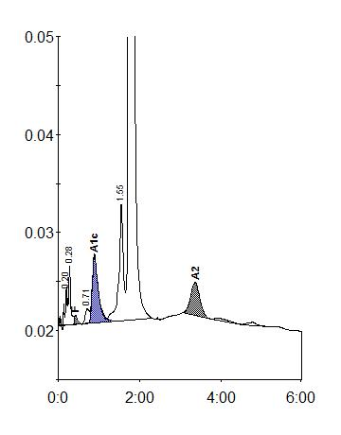

|  |  |  |  |  |  |  |
| --- | --- | --- | --- | --- | --- | --- |
| Peak table - ID: KARAMJIT | | |  |  |  |  |
| Peak | R.time | | Height | | Area | Area % |
| A1a | 0.20 | | 3867 | | 12754 | 0.6 |
| A1b | 0.28 | | 6134 | | 21171 | 0.9 |
| F | 0.43 | | 912 |  | 5427 | < 0.8 * |
| LA1c/CHb-1 | 0.71 | | 1452 | | 10024 | 0.4 |
| A1c | 0.89 | | 6966 | | 72878 | 4.9 |
| P3 | 1.55 | | 11936 | | 93364 | 4.1 |
| A0 | 1.75 | | 407092 | | 2007916 | 88.1 |
| A2 | 3.37 | | 3419 | | 54739 | 2.7 |
| Total Area: | 2278273 | |  |  |  |  |
|  |  | |  |  |  |  |
| Concentration: |  | % |  |  |  |  |
|  |  |  |  |  |  |  |
| F |  | < 0.8 * |  |  |  |  |
|  |  |  |  |  |  |  |
| A1c |  | 4.9 |  |  |  |  |
|  |  |  |  |  |  |  |
| A2 |  | 2.7 |  |  |  |  |
|  |  |  |  |  |  |  |