**Patient report**

Bio-Rad

D-10

S/N: #DJ6F040603

Sample ID:

Injection date

Injection #: 1

Rack #: ---

DATE: 11/13/2018

TIME: 07:15 PM

Software version: 4.20-2

13120017

11/13/2018 05:43 PM

Method: HbA2/F

Rack position: 1

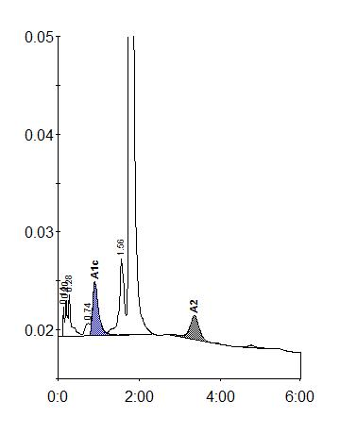

|  |  |  |  |  |  |
| --- | --- | --- | --- | --- | --- |
| Peak table - ID: 06120011 | | |  |  |  |
| Peak | R.time | | Height | Area | Area % |
| Unknown | 0.14 | | 3095 | 6032 | 0.4 |
| A1a | 0.20 | | 3792 | 12878 | 0.8 |
| A1b | 0.28 | | 4298 | 19513 | 1.2 |
| LA1c/CHb-1 | 0.74 | | 1281 | 10461 | 0.6 |
| A1c | 0.91 | | 5478 | 55871 | 5.3 |
| P3 | 1.56 | | 7727 | 66602 | 4.1 |
| A0 | 1.77 | | 298647 | 1426255 | 87.1 |
| A2 | 3.35 | | 2438 | 39339 | 2.7 |
| Total Area: | 1636951 | |  |  |  |
|  |  |  |  |  |  |
| Concentration: |  | % |  |  |  |
|  |  |  |  |  |  |
| A1c |  | 5.3 |  |  |  |
|  |  |  |  |  |  |
| A2 |  | 2.7 |  |  |  |
|  |  |  |  |  |  |