**Patient report**

Bio-Rad

D-10

S/N: #DJ6F040603

Sample ID:

Injection date

Injection #: 9

Rack #: ---

DATE: 04/17/2019

TIME: 09:53 AM

Software version: 4.20-2

2309

04/17/2019 09:49 AM

Method: HbA2/F

Rack position: 1

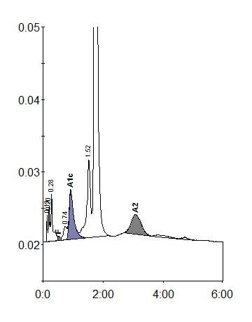

|  |  |  |  |  |  |  |
| --- | --- | --- | --- | --- | --- | --- |
| Peak table - ID: 2309 | | |  |  |  |  |
| Peak | R.time | | Height | | Area | Area % |
| Unknown | 0.13 | | 3658 | | 6247 | 0.3 |
| A1a | 0.20 | | 4909 | | 11088 | 0.5 |
| A1b | 0.28 | | 6428 | | 29176 | 1.4 |
| F | 0.51 | | 584 |  | 5977 | < 0.8 * |
| LA1c/CHb-1 | 0.74 | | 1829 | | 14696 | 0.7 |
| A1c | 0.92 | | 6721 | | 73514 | 5.1 |
| P3 | 1.52 | | 10798 | | 93496 | 4.4 |
| A0 | 1.73 | | 398628 | | 1815398 | 86.0 |
| A2 | 3.07 | | 2645 | | 60949 | 2.7 |
| Total Area: | 2110541 | |  |  |  |  |
|  |  | |  |  |  |  |
| Concentration: |  | % |  |  |  |  |
|  |  |  |  |  |  |  |
| F |  | < 0.8 * |  |  |  |  |
|  |  |  |  |  |  |  |
| A1c |  | 5.1 |  |  |  |  |
|  |  |  |  |  |  |  |
| A2 |  | 2.7 |  |  |  |  |
|  |  |  |  |  |  |  |